Caribou Lake Rusty Crayfish

July 2020 rusty crayfish traps were set in Murmur Creek and Bigsby Lake to determine if the invasive crayfish has traveled out of infested Pike Lake. Rusty crayfish were found.
On August 17th 8 crayfish traps were set throughout Caribou Lake. Traps were checked on August 18th.
Trap # | Location (UTM) | Number of O. rusticus | Number of Natives
1 | 675045, 5287638 | 8 | 42 O. virilis
2 | 675482, 5287928 | 14 | 15 O. virilis
3 | 676085, 5288276 | 23 | 6 O. virilis
4 | 676587, 5288415 | 34 | 6 O. virilis
5 | 676605, 5288418 | 7 | 1 O. virilis
6 | 676744, 5288525 | 8 | 15 O. virilis
7 | 676515, 5288029 | 30 | 12 O. virilis
8 | 675088, 5286411 | 0 | 26 O. virilis
*The invasive rusty crayfish (Orconectes rusticus) was found*

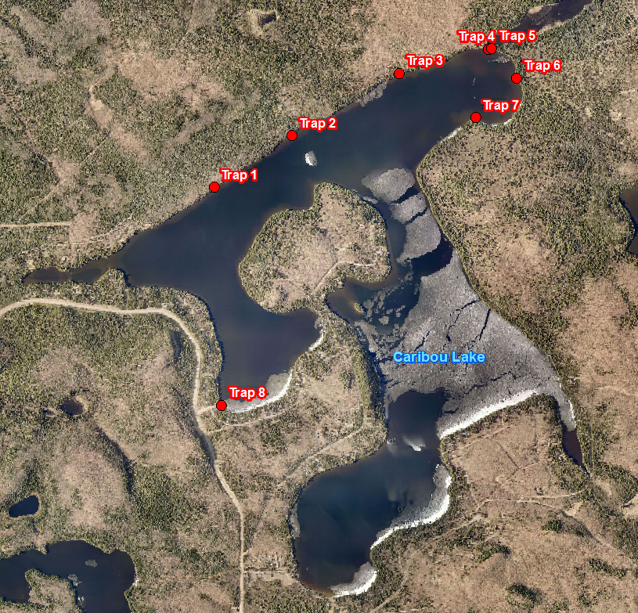

Caribou Lake Rusty Crayfish
Proposed Management Plan: Extensive harvesting in early summer 2021

The most efficient time of year for crayfish trapping is in early summer. This is when females are gravid, and crayfish are active and most hungry.
With this approach trapping intensively for several days or weeks will remove the females before eggs are laid and remove the larger crayfish. The remaining crayfish will be smaller in size and more easily predated upon by fish species. Caribou Lake has a healthy bass fishery similar to Hungry Jack Lake. Hungry Jack Lake is also infested with rusty crayfish, but the invasive crayfish is not a nuisance because the population is under control by fish management.
There is a study that proved this method works:
Fish predation and trapping for rusty crayfish (Orconectes rusticus) control: a whole-lake experiment
Catherine L. Hein, Brian M. Roth, Anthony R. Ives, and M. Jake Vander Zanden

AIS leaders have confidence that with annual early summer harvesting, rusty crayfish will be managed.

The AIS coordinator will work with Caribou Lake Association and government agencies to organize and accomplish the crayfish harvesting.

